BISC 577a

Kalinga Pavan Thushara Silva

Second assignment for 3rd section

(1).

(a).

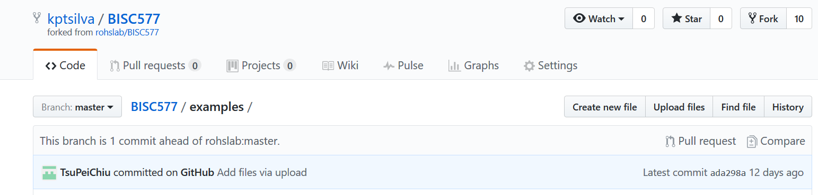

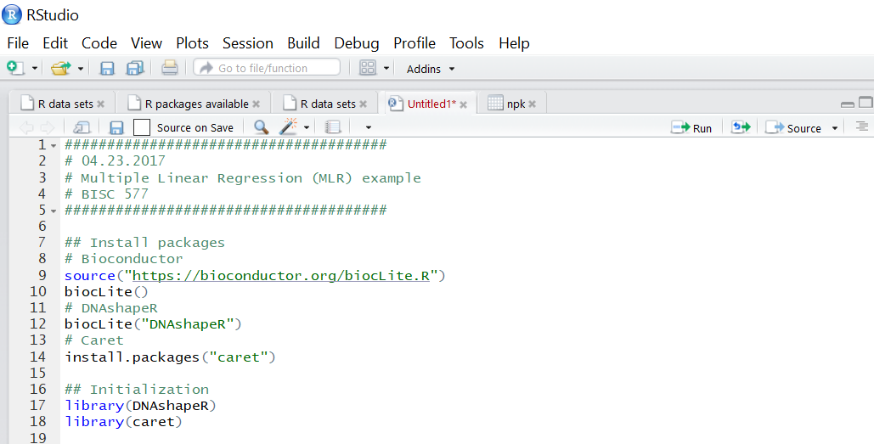

(b).



(2).

(a).

SELEX-seq: For characterizing the specificities of the DNA binding and their relative affinities to a DNA sequence an experimental and computational technique known as SELEX-seq was introduced. It combines the traditional SELEX (Systematic Evolution of Ligands by Exponential Enrichment) method with next-generation sequence technology and is ideal for exploring DNA binding preferences of multiprotein complexes.

PBM: Protien Binding Microarray. This is a standard method for inferring transcription factor binding in vivo. An array of protiens are captured and bound to a surface and a probe molecule will create a response to detect the level of activity. This is a high throughput method for identifying the DNA binding to protiens in vitro.

(b). ChIP-Seq: Chromatin immunoprecipitation. Used to map global binding sites of a protein. The basic procedure in Chip-seq is crosslinking proteins to DNA, then shearing the DNA strands by sonication, adding bead-attached antibodies to immunoprecipitated target protein and finally purifying and sequencing the sequence.

(c). In general each technique has an advantage over the other in certain scenarios. For instance, the ChiP method is best to finding how transcription factors and other chromatin associated proteins influences phenotype-affecting mechanisms. It is a more global approach under specific conditions. The disadvantage here would be the use of specific antibodies.

In PBM the major advantage is that a large number of proteins can be tracked in parallel. They are rapid, automated, economical and highly sensitive. As proteins are highly sensitive to changes in their microenvironment, there is challenge in maintaining protein arrays in a stable condition over extended periods of time.

In SELEX the technique is used to evolve aptamers of high binding affinity to a variety of target ligands. Additionally SELEX has been used to obtain highly specific catalytic DNA or DNAzymes. As a disadvantage the selection of extremely high sub-nanomolar binding affinity entities of SELEX may not in fact improve specificity for the target molecule.

(3).

(a), (b), (c), (d)



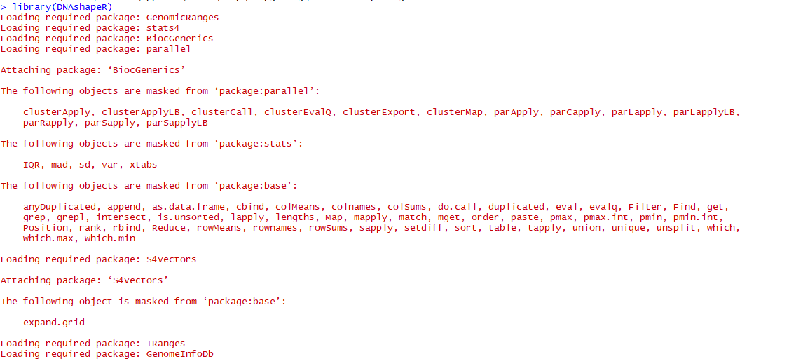

F:\computational physics\part5.PNG

(4).

(a). Feature vector:

(A) Mad

1-mer:

[,1] [,2] [,3] [,4] [,5] [,6] [,7] [,8] [,9] [,10] [,11] [,12] [,13]

seq1 0 0 1 0 1 0 0 0 1 0 0 0 0

seq2 0 0 0 1 0 1 0 0 0 1 0 0 0

seq3 0 0 1 0 0 0 1 0 0 1 0 0 0

seq4 0 0 1 0 0 1 0 0 1 0 0 0 0

seq5 0 0 1 0 0 0 1 0 1 0 0 0 1

seq6 0 0 1 0 0 1 0 0 1 0 0 0 0

[,14] [,15] [,16] [,17] [,18] [,19] [,20] [,21] [,22] [,23] [,24]

seq1 0 1 0 0 1 0 0 0 1 0 0

seq2 1 0 0 0 0 1 0 0 0 1 0

seq3 0 1 0 0 1 0 0 0 0 0 1

seq4 0 1 0 0 1 0 0 0 0 0 1

seq5 0 0 0 0 0 0 1 0 0 0 1

seq6 0 1 0 0 1 0 0 1 0 0 0

[,25] [,26] [,27] [,28] [,29] [,30] [,31] [,32] [,33] [,34] [,35]

seq1 0 1 0 0 0 0 0 1 0 0 1

seq2 0 0 1 0 0 0 1 0 0 1 0

seq3 0 0 1 0 0 1 0 0 0 1 0

seq4 0 1 0 0 0 0 1 0 0 1 0

seq5 1 0 0 0 0 1 0 0 0 1 0

seq6 1 0 0 0 0 1 0 0 0 0 1

[,36] [,37] [,38] [,39] [,40] [,41] [,42] [,43] [,44] [,45] [,46]

seq1 0 0 0 1 0 0 1 0 0 0 0

seq2 0 0 0 0 1 1 0 0 0 0 0

seq3 0 0 0 1 0 0 0 1 0 1 0

seq4 0 0 1 0 0 0 1 0 0 0 0

seq5 0 0 0 0 1 0 0 0 1 0 1

seq6 0 0 0 1 0 0 0 1 0 1 0

[,47] [,48] [,49] [,50] [,51] [,52] [,53] [,54] [,55] [,56] [,57]

seq1 1 0 0 0 1 0 0 0 1 0 0

seq2 1 0 1 0 0 0 0 0 1 0 0

seq3 0 0 0 1 0 0 0 0 0 1 0

seq4 1 0 0 0 1 0 0 0 1 0 0

seq5 0 0 1 0 0 0 0 0 0 1 0

seq6 0 0 0 0 1 0 1 0 0 0 0

[,58] [,59] [,60] [,61] [,62] [,63] [,64] [,65] [,66] [,67] [,68]

seq1 0 1 0 0 1 0 0 0 0 1 0

seq2 0 1 0 0 1 0 0 1 0 0 0

seq3 0 1 0 0 1 0 0 0 0 1 0

seq4 1 0 0 0 1 0 0 1 0 0 0

seq5 1 0 0 0 1 0 0 1 0 0 0

seq6 0 1 0 0 1 0 0 0 0 1 0

[,69] [,70] [,71] [,72] [,73] [,74] [,75] [,76] [,77] [,78] [,79]

seq1 0 1 0 0 0 0 1 0 0 0 0

seq2 0 0 0 1 0 0 1 0 0 0 0

seq3 0 1 0 0 0 0 1 0 0 0 0

seq4 0 1 0 0 0 0 1 0 0 1 0

seq5 0 1 0 0 1 0 0 0 0 0 0

seq6 0 1 0 0 0 0 1 0 0 0 0

[,80] [,81] [,82] [,83] [,84] [,85] [,86] [,87] [,88] [,89] [,90]

seq1 1 0 0 1 0 0 1 0 0 0 1

seq2 1 0 0 1 0 0 0 1 0 1 0

seq3 1 0 0 1 0 0 0 1 0 1 0

seq4 0 0 0 1 0 0 0 1 0 0 0

seq5 1 0 0 1 0 0 0 1 0 0 0

seq6 1 0 0 1 0 0 1 0 0 0 0

[,91] [,92] [,93] [,94] [,95] [,96] [,97] [,98] [,99] [,100] [,101]

seq1 0 0 0 1 0 0 0 0 1 0 0

seq2 0 0 0 1 0 0 0 0 0 1 0

seq3 0 0 0 0 1 0 0 0 0 1 0

seq4 0 1 0 0 1 0 0 1 0 0 0

seq5 0 1 0 0 0 1 0 0 1 0 1

seq6 1 0 0 1 0 0 0 1 0 0 0

[,102] [,103] [,104] [,105] [,106] [,107] [,108] [,109] [,110] [,111]

seq1 1 0 0 0 1 0 0 0 0 1

seq2 1 0 0 1 0 0 0 0 0 1

seq3 0 1 0 0 0 1 0 0 1 0

seq4 1 0 0 0 0 1 0 0 0 1

seq5 0 0 0 1 0 0 0 0 0 1

seq6 0 1 0 0 1 0 0 0 1 0

[,112] [,113] [,114] [,115] [,116] [,117] [,118] [,119] [,120] [,121]

seq1 0 0 1 0 0 0 1 0 0 0

seq2 0 0 0 1 0 1 0 0 0 0

seq3 0 0 0 1 0 0 1 0 0 0

seq4 0 0 1 0 0 0 1 0 0 0

seq5 0 0 1 0 0 0 0 0 1 0

seq6 0 0 1 0 0 0 1 0 0 1

[,122] [,123] [,124] [,125] [,126] [,127] [,128] [,129] [,130] [,131]

seq1 0 1 0 0 1 0 0 0 1 0

seq2 0 1 0 0 0 1 0 1 0 0

seq3 0 1 0 0 1 0 0 0 0 0

seq4 1 0 0 0 0 0 1 0 1 0

seq5 0 1 0 0 0 1 0 0 1 0

seq6 0 0 0 0 0 1 0 1 0 0

[,132] [,133] [,134] [,135] [,136] [,137] [,138] [,139] [,140] [,141]

seq1 0 0 0 1 0 0 1 0 0 0

seq2 0 0 0 0 1 0 0 1 0 1

seq3 1 0 0 1 0 0 1 0 0 0

seq4 0 0 0 1 0 0 0 1 0 0

seq5 0 0 0 0 1 0 0 1 0 0

seq6 0 0 1 0 0 0 0 1 0 1

[,142] [,143] [,144]

seq1 1 0 0

seq2 0 0 0

seq3 0 0 1

seq4 1 0 0

seq5 0 1 0

seq6 0 0 0

1-mer+shape

[,1] [,2] [,3] [,4] [,5] [,6] [,7] [,8] [,9] [,10] [,11] [,12] [,13]

seq1 0 0 1 0 0 0 1 0 0 0 1 0 0

seq2 0 1 0 0 0 0 1 0 0 0 1 0 0

seq3 0 0 1 0 0 0 1 0 0 1 0 0 0

[,14] [,15] [,16] [,17] [,18] [,19] [,20] [,21] [,22] [,23] [,24]

seq1 1 0 0 1 0 0 0 0 0 0 1

seq2 0 1 0 0 0 1 0 1 0 0 0

seq3 0 1 0 0 0 1 0 0 1 0 0

[,25] [,26] [,27] [,28] [,29] [,30] [,31] [,32] [,33] [,34] [,35]

seq1 0 0 1 0 1 0 0 0 1 0 0

seq2 0 0 1 0 0 0 1 0 1 0 0

seq3 0 1 0 0 0 1 0 0 0 0 1

[,36] [,37] [,38] [,39] [,40] [,41] [,42] [,43] [,44] [,45] [,46]

seq1 0 1 0 0 0 0 0 1 0 0 1

seq2 0 0 0 1 0 0 1 0 0 0 1

seq3 0 0 0 1 0 0 0 1 0 0 1

[,47] [,48] [,49] [,50] [,51] [,52] [,53] [,54] [,55] [,56] [,57]

seq1 0 0 0 1 0 0 1 0 0 0 0

seq2 0 0 1 0 0 0 0 1 0 0 0

seq3 0 0 1 0 0 0 0 0 0 1 0

[,58] [,59] [,60] [,61] [,62] [,63] [,64] [,65] [,66] [,67] [,68]

seq1 1 0 0 0 1 0 0 0 0 0 1

seq2 1 0 0 0 1 0 0 1 0 0 0

seq3 1 0 0 0 1 0 0 1 0 0 0

[,69] [,70] [,71] [,72] [,73] [,74] [,75] [,76] [,77] [,78] [,79]

seq1 0 1 0 0 0 0 1 0 0 0 0

seq2 0 1 0 0 0 0 1 0 0 1 0

seq3 0 1 0 0 0 0 1 0 0 0 0

[,80] [,81] [,82] [,83] [,84] [,85] [,86] [,87] [,88] [,89] [,90]

seq1 1 0 0 1 0 0 0 1 0 0 0

seq2 0 0 0 1 0 0 1 0 0 0 1

seq3 1 0 0 1 0 0 0 1 0 0 0

[,91] [,92] [,93] [,94] [,95] [,96] [,97] [,98] [,99] [,100] [,101]

seq1 0 1 0 0 0 1 0 0 0 1 0

seq2 0 0 1 0 0 0 0 1 0 0 1

seq3 1 0 0 0 0 1 0 1 0 0 0

[,102] [,103] [,104] [,105] [,106] [,107] [,108] [,109] [,110] [,111]

seq1 0 0 1 0 0 1 0 0 1 0

seq2 0 0 0 0 0 1 0 0 1 0

seq3 0 1 0 0 0 1 0 0 0 1

[,112] [,113] [,114] [,115] [,116] [,117] [,118] [,119] [,120] [,121]

seq1 0 1 0 0 0 0 0 1 0 0

seq2 0 1 0 0 0 1 0 0 0 0

seq3 0 0 1 0 0 0 0 0 1 0

[,122] [,123] [,124] [,125] [,126] [,127] [,128] [,129] [,130] [,131]

seq1 1 0 0 1 0 0 0 1 0 0

seq2 0 1 0 0 0 0 1 0 1 0

seq3 1 0 0 0 1 0 0 0 0 0

[,132] [,133] [,134] [,135] [,136] [,137] [,138] [,139] [,140] [,141]

seq1 0 0 0 1 0 0 0 0 1 0

seq2 0 0 1 0 0 0 0 0 1 0

seq3 1 0 0 1 0 0 0 1 0 0

[,142] [,143] [,144] [,145] [,146] [,147] [,148] [,149]

seq1 0 1 0 0.6477612 0.7402985 0.7910448 0.7223881 0.7910448

seq2 0 1 0 0.6238806 0.5701493 0.5970149 0.6208955 0.5820896

seq3 0 0 1 0.7283582 0.7522388 0.6298507 0.5731343 0.6268657

[,150] [,151] [,152] [,153] [,154] [,155] [,156]

seq1 0.7611940 0.4507463 0.3522388 0.3940299 0.5014925 0.7791045 0.8089552

seq2 0.5313433 0.6567164 0.5432836 0.5014925 0.7791045 0.8089552 0.5731343

seq3 0.6985075 0.6985075 0.6268657 0.6477612 0.7402985 0.7552239 0.5940299

[,157] [,158] [,159] [,160] [,161] [,162] [,163]

seq1 0.4686567 0.4537313 0.6955224 0.6805970 0.7283582 0.8328358 0.7552239

seq2 0.5402985 0.7641791 0.8328358 0.7164179 0.7014925 0.8029851 0.7641791

seq3 0.6238806 0.8149254 0.8328358 0.5970149 0.5970149 0.8328358 0.7641791

[,164] [,165] [,166] [,167] [,168] [,169] [,170]

seq1 0.4417910 0.3611940 0.3582090 0.5701493 0.7641791 0.8746269 0.8776119

seq2 0.6597015 0.7791045 0.8805970 0.7373134 0.7343284 0.7223881 0.6656716

seq3 0.5402985 0.4776119 0.5880597 0.8029851 0.7074627 0.6268657 0.5253731

[,171] [,172] [,173] [,174] [,175] [,176] [,177]

seq1 0.8417910 0.7223881 0.6656716 0.7761194 0.4985075 0.3850746 0.8489078

seq2 0.7761194 0.4985075 0.2656716 0.4955224 0.5850746 0.6179104 0.8834951

seq3 0.5432836 0.6567164 0.5313433 0.6179104 0.7611940 0.6985075 0.8118932

[,178] [,179] [,180] [,181] [,182] [,183] [,184]

seq1 0.8125000 0.4296117 0.4399272 0.6334951 0.3458738 0.2779126 0.3598301

seq2 0.9144417 0.7226942 0.6529126 0.9751214 0.7099515 0.6334951 0.9696602

seq3 0.7754854 0.8367718 0.8847087 0.8361650 0.8040049 0.8040049 0.8361650

[,185] [,186] [,187] [,188] [,189] [,190] [,191]

seq1 0.9077670 0.8343447 0.7572816 0.5703883 0.5989078 0.9484223 0.6183252

seq2 0.8343447 0.7572816 0.5703883 0.6444175 0.7967233 0.8234223 0.5242718

seq3 0.8489078 0.8125000 0.5406553 0.5376214 0.6559466 0.7906553 0.5242718

[,192] [,193] [,194] [,195] [,196] [,197] [,198]

seq1 0.6074029 0.5194175 0.5242718 0.6984223 0.4641990 0.2487864 0.1237864

seq2 0.5175971 0.7148058 0.7457524 0.7961165 0.8209951 0.7572816 0.5570388

seq3 0.4690534 0.4690534 0.5242718 0.8234223 0.7967233 0.6783981 0.5109223

[,199] [,200] [,201] [,202] [,203] [,204] [,205]

seq1 0.1650485 0.3416262 0.7712379 0.7785194 0.5916262 0.8974515 0.7979369

seq2 0.5091019 0.5564320 0.8974515 0.7979369 0.4010922 0.3822816 0.7548544

seq3 0.5928398 0.8246359 0.8361650 0.8513350 0.9696602 0.6334951 0.7099515

[,206] [,207] [,208] [,209] [,210] [,211] [,212]

seq1 0.4010922 0.3822816 0.7299757 0.3945381 0.3893085 0.7576990 0.2562464

seq2 0.5564320 0.6747573 0.9472087 0.3951191 0.3794306 0.4334689 0.3881464

seq3 0.9472087 0.6656553 0.7324029 0.3805927 0.6310285 0.4218478 0.3701336

[,213] [,214] [,215] [,216] [,217] [,218] [,219]

seq1 0.8361418 0.5136549 0.3631610 0.2068565 0.2754213 0.2597327 0.3829169

seq2 0.3201627 0.4195235 0.3759442 0.3381755 0.2969204 0.3829169 0.6589192

seq3 0.3794306 0.4020918 0.6101104 0.4020918 0.3962812 0.3893085 0.7280651

[,220] [,221] [,222] [,223] [,224] [,225] [,226]

seq1 0.6589192 0.3294596 0.3817548 0.3160953 0.4032539 0.7960488 0.3666473

seq2 0.3370134 0.4253341 0.3858222 0.6653109 0.3649041 0.7658338 0.4241720

seq3 0.2382336 0.4369553 0.4677513 0.6717025 0.3393376 0.8256827 0.3393376

[,227] [,228] [,229] [,230] [,231] [,232] [,233]

seq1 0.6891342 0.4665892 0.2667054 0.2492737 0.3126089 0.3271354 0.7466589

seq2 0.6717025 0.3933759 0.4055782 0.6629866 0.3829169 0.7902382 0.3829169

seq3 0.6653109 0.3858222 0.4049971 0.2963393 0.3910517 0.6943637 0.3974433

[,234] [,235] [,236] [,237] [,238] [,239] [,240]

seq1 0.4416037 0.7007554 0.3829169 0.3660662 0.7373620 0.2951772 0.3486345

seq2 0.3660662 0.7373620 0.2951772 0.3131900 0.2277745 0.3625799 0.4398605

seq3 0.3910517 0.3230680 0.3381755 0.3759442 0.4288205 0.3335270 0.6583382

[,241] [,242] [,243] [,244] [,245] [,246]

seq1 0.2359094 0.4050633 0.75105485 0.5344585 0.09845288 0.57383966

seq2 0.3358512 0.3206751 0.37130802 0.3699015 0.65260197 0.07594937

seq3 0.4607786 0.7552743 0.20393812 0.3361463 0.81434599 0.38396624

[,247] [,248] [,249] [,250] [,251] [,252]

seq1 0.5907173 0.69901547 0.75808720 0.2405063 0.9479606 0.32208158

seq2 0.4514768 0.71026723 0.06188467 0.9029536 0.3220816 0.46272855

seq3 0.3375527 0.22362869 0.33755274 0.4022504 0.7510549 0.51758087

[,253] [,254] [,255] [,256] [,257] [,258] [,259]

seq1 0.4627286 0.4472574 0.5836850 0.07735584 0.6343179 0.4078762 0.3811533

seq2 0.4345992 0.5035162 0.3656821 0.45007032 0.3783404 0.3277075 0.6835443

seq3 0.1490858 0.7398031 0.3909986 0.46694796 0.4008439 0.4978903 0.4008439

[,260] [,261] [,262] [,263] [,264] [,265]

seq1 0.4556962 0.5189873 0.6736990 0.80309423 0.8565401 0.6272855

seq2 0.2025316 0.7524613 0.3220816 0.50070323 0.3473980 0.5879044

seq3 0.4500703 0.3656821 0.5007032 0.54008439 0.6526020 0.2672293

[,266] [,267] [,268] [,269] [,270] [,271]

seq1 0.49789030 0.64978903 0.5007032 0.04500703 0.8241913 0.4852321

seq2 0.04922644 0.82419128 0.4852321 0.55836850 0.3094233 0.5991561

seq3 0.36146273 0.37974684 0.8804501 0.06188467 0.7102672 0.4542897

[,272] [,273] [,274]

seq1 0.55836850 0.3066104 0.55836850

seq2 0.69901547 0.4810127 0.03797468

seq3 0.03516174 0.4486639 0.48523207

(B) Max

1-mer:

[,1] [,2] [,3] [,4] [,5] [,6] [,7] [,8] [,9] [,10] [,11] [,12] [,13]

seq1 0 0 1 0 1 0 0 0 1 0 0 0 0

seq2 0 0 0 1 0 1 0 0 0 1 0 0 0

seq3 0 0 1 0 0 0 1 0 0 1 0 0 0

seq4 0 0 1 0 0 1 0 0 1 0 0 0 0

seq5 0 0 1 0 0 0 1 0 1 0 0 0 1

seq6 0 0 1 0 0 1 0 0 1 0 0 0 0

[,14] [,15] [,16] [,17] [,18] [,19] [,20] [,21] [,22] [,23] [,24]

seq1 0 1 0 0 1 0 0 0 1 0 0

seq2 1 0 0 0 0 1 0 0 0 1 0

seq3 0 1 0 0 1 0 0 0 0 0 1

seq4 0 1 0 0 1 0 0 0 0 0 1

seq5 0 0 0 0 0 0 1 0 0 0 1

seq6 0 1 0 0 1 0 0 1 0 0 0

[,25] [,26] [,27] [,28] [,29] [,30] [,31] [,32] [,33] [,34] [,35]

seq1 0 1 0 0 0 0 0 1 0 0 1

seq2 0 0 1 0 0 0 1 0 0 1 0

seq3 0 0 1 0 0 1 0 0 0 1 0

seq4 0 1 0 0 0 0 1 0 0 1 0

seq5 1 0 0 0 0 1 0 0 0 1 0

seq6 1 0 0 0 0 1 0 0 0 0 1

[,36] [,37] [,38] [,39] [,40] [,41] [,42] [,43] [,44] [,45] [,46]

seq1 0 0 0 1 0 0 1 0 0 0 0

seq2 0 0 0 0 1 1 0 0 0 0 0

seq3 0 0 0 1 0 0 0 1 0 1 0

seq4 0 0 1 0 0 0 1 0 0 0 0

seq5 0 0 0 0 1 0 0 0 1 0 1

seq6 0 0 0 1 0 0 0 1 0 1 0

[,47] [,48] [,49] [,50] [,51] [,52] [,53] [,54] [,55] [,56] [,57]

seq1 1 0 0 0 1 0 0 0 1 0 0

seq2 1 0 1 0 0 0 0 0 1 0 0

seq3 0 0 0 1 0 0 0 0 0 1 0

seq4 1 0 0 0 1 0 0 0 1 0 0

seq5 0 0 1 0 0 0 0 0 0 1 0

seq6 0 0 0 0 1 0 1 0 0 0 0

[,58] [,59] [,60] [,61] [,62] [,63] [,64] [,65] [,66] [,67] [,68]

seq1 0 1 0 0 1 0 0 0 0 1 0

seq2 0 1 0 0 1 0 0 1 0 0 0

seq3 0 1 0 0 1 0 0 0 0 1 0

seq4 1 0 0 0 1 0 0 1 0 0 0

seq5 1 0 0 0 1 0 0 1 0 0 0

seq6 0 1 0 0 1 0 0 0 0 1 0

[,69] [,70] [,71] [,72] [,73] [,74] [,75] [,76] [,77] [,78] [,79]

seq1 0 1 0 0 0 0 1 0 0 0 0

seq2 0 0 0 1 0 0 1 0 0 0 0

seq3 0 1 0 0 0 0 1 0 0 0 0

seq4 0 1 0 0 0 0 1 0 0 1 0

seq5 0 1 0 0 1 0 0 0 0 0 0

seq6 0 1 0 0 0 0 1 0 0 0 0

[,80] [,81] [,82] [,83] [,84] [,85] [,86] [,87] [,88] [,89] [,90]

seq1 1 0 0 1 0 0 1 0 0 0 1

seq2 1 0 0 1 0 0 0 1 0 1 0

seq3 1 0 0 1 0 0 0 1 0 1 0

seq4 0 0 0 1 0 0 0 1 0 0 0

seq5 1 0 0 1 0 0 0 1 0 0 0

seq6 1 0 0 1 0 0 1 0 0 0 0

[,91] [,92] [,93] [,94] [,95] [,96] [,97] [,98] [,99] [,100] [,101]

seq1 0 0 0 1 0 0 0 0 1 0 0

seq2 0 0 0 1 0 0 0 0 0 1 0

seq3 0 0 0 0 1 0 0 0 0 1 0

seq4 0 1 0 0 1 0 0 1 0 0 0

seq5 0 1 0 0 0 1 0 0 1 0 1

seq6 1 0 0 1 0 0 0 1 0 0 0

[,102] [,103] [,104] [,105] [,106] [,107] [,108] [,109] [,110] [,111]

seq1 1 0 0 0 1 0 0 0 0 1

seq2 1 0 0 1 0 0 0 0 0 1

seq3 0 1 0 0 0 1 0 0 1 0

seq4 1 0 0 0 0 1 0 0 0 1

seq5 0 0 0 1 0 0 0 0 0 1

seq6 0 1 0 0 1 0 0 0 1 0

[,112] [,113] [,114] [,115] [,116] [,117] [,118] [,119] [,120] [,121]

seq1 0 0 1 0 0 0 1 0 0 0

seq2 0 0 0 1 0 1 0 0 0 0

seq3 0 0 0 1 0 0 1 0 0 0

seq4 0 0 1 0 0 0 1 0 0 0

seq5 0 0 1 0 0 0 0 0 1 0

seq6 0 0 1 0 0 0 1 0 0 1

[,122] [,123] [,124] [,125] [,126] [,127] [,128] [,129] [,130] [,131]

seq1 0 1 0 0 1 0 0 0 1 0

seq2 0 1 0 0 0 1 0 1 0 0

seq3 0 1 0 0 1 0 0 0 0 0

seq4 1 0 0 0 0 0 1 0 1 0

seq5 0 1 0 0 0 1 0 0 1 0

seq6 0 0 0 0 0 1 0 1 0 0

[,132] [,133] [,134] [,135] [,136] [,137] [,138] [,139] [,140] [,141]

seq1 0 0 0 1 0 0 1 0 0 0

seq2 0 0 0 0 1 0 0 1 0 1

seq3 1 0 0 1 0 0 1 0 0 0

seq4 0 0 0 1 0 0 0 1 0 0

seq5 0 0 0 0 1 0 0 1 0 0

seq6 0 0 1 0 0 0 0 1 0 1

[,142] [,143] [,144]

seq1 1 0 0

seq2 0 0 0

seq3 0 0 1

seq4 1 0 0

seq5 0 1 0

seq6 0 0 0

1-mer+shape:

[,1] [,2] [,3] [,4] [,5] [,6] [,7] [,8] [,9] [,10] [,11] [,12] [,13]

seq1 0 0 1 0 1 0 0 0 1 0 0 0 0

seq2 0 0 0 1 0 1 0 0 0 1 0 0 0

seq3 0 0 1 0 0 0 1 0 0 1 0 0 0

[,14] [,15] [,16] [,17] [,18] [,19] [,20] [,21] [,22] [,23] [,24]

seq1 0 1 0 0 1 0 0 0 1 0 0

seq2 1 0 0 0 0 1 0 0 0 1 0

seq3 0 1 0 0 1 0 0 0 0 0 1

[,25] [,26] [,27] [,28] [,29] [,30] [,31] [,32] [,33] [,34] [,35]

seq1 0 1 0 0 0 0 0 1 0 0 1

seq2 0 0 1 0 0 0 1 0 0 1 0

seq3 0 0 1 0 0 1 0 0 0 1 0

[,36] [,37] [,38] [,39] [,40] [,41] [,42] [,43] [,44] [,45] [,46]

seq1 0 0 0 1 0 0 1 0 0 0 0

seq2 0 0 0 0 1 1 0 0 0 0 0

seq3 0 0 0 1 0 0 0 1 0 1 0

[,47] [,48] [,49] [,50] [,51] [,52] [,53] [,54] [,55] [,56] [,57]

seq1 1 0 0 0 1 0 0 0 1 0 0

seq2 1 0 1 0 0 0 0 0 1 0 0

seq3 0 0 0 1 0 0 0 0 0 1 0

[,58] [,59] [,60] [,61] [,62] [,63] [,64] [,65] [,66] [,67] [,68]

seq1 0 1 0 0 1 0 0 0 0 1 0

seq2 0 1 0 0 1 0 0 1 0 0 0

seq3 0 1 0 0 1 0 0 0 0 1 0

[,69] [,70] [,71] [,72] [,73] [,74] [,75] [,76] [,77] [,78] [,79]

seq1 0 1 0 0 0 0 1 0 0 0 0

seq2 0 0 0 1 0 0 1 0 0 0 0

seq3 0 1 0 0 0 0 1 0 0 0 0

[,80] [,81] [,82] [,83] [,84] [,85] [,86] [,87] [,88] [,89] [,90]

seq1 1 0 0 1 0 0 1 0 0 0 1

seq2 1 0 0 1 0 0 0 1 0 1 0

seq3 1 0 0 1 0 0 0 1 0 1 0

[,91] [,92] [,93] [,94] [,95] [,96] [,97] [,98] [,99] [,100] [,101]

seq1 0 0 0 1 0 0 0 0 1 0 0

seq2 0 0 0 1 0 0 0 0 0 1 0

seq3 0 0 0 0 1 0 0 0 0 1 0

[,102] [,103] [,104] [,105] [,106] [,107] [,108] [,109] [,110] [,111]

seq1 1 0 0 0 1 0 0 0 0 1

seq2 1 0 0 1 0 0 0 0 0 1

seq3 0 1 0 0 0 1 0 0 1 0

[,112] [,113] [,114] [,115] [,116] [,117] [,118] [,119] [,120] [,121]

seq1 0 0 1 0 0 0 1 0 0 0

seq2 0 0 0 1 0 1 0 0 0 0

seq3 0 0 0 1 0 0 1 0 0 0

[,122] [,123] [,124] [,125] [,126] [,127] [,128] [,129] [,130] [,131]

seq1 0 1 0 0 1 0 0 0 1 0

seq2 0 1 0 0 0 1 0 1 0 0

seq3 0 1 0 0 1 0 0 0 0 0

[,132] [,133] [,134] [,135] [,136] [,137] [,138] [,139] [,140] [,141]

seq1 0 0 0 1 0 0 1 0 0 0

seq2 0 0 0 0 1 0 0 1 0 1

seq3 1 0 0 1 0 0 1 0 0 0

[,142] [,143] [,144] [,145] [,146] [,147] [,148] [,149]

seq1 1 0 0 0.5880597 0.3940299 0.5253731 0.5611940 0.5970149

seq2 0 0 0 0.6268657 0.6985075 0.6985075 0.6238806 0.5880597

seq3 0 0 1 0.7641791 0.6955224 0.6805970 0.8417910 0.7641791

[,150] [,151] [,152] [,153] [,154] [,155] [,156]

seq1 0.7611940 0.7701493 0.6597015 0.7283582 0.7313433 0.6238806 0.5880597

seq2 0.5253731 0.6417910 0.8417910 0.8925373 0.7641791 0.6328358 0.5970149

seq3 0.6925373 0.7492537 0.7582090 0.6656716 0.4955224 0.6417910 0.7611940

[,157] [,158] [,159] [,160] [,161] [,162] [,163]

seq1 0.6298507 0.7641791 0.8029851 0.7014925 0.7164179 0.8626866 0.8388060

seq2 0.5880597 0.7402985 0.7910448 0.6388060 0.6865672 0.8805970 0.8149254

seq3 0.8417910 0.8537313 0.8029851 0.7014925 0.7164179 0.8328358 0.8149254

[,164] [,165] [,166] [,167] [,168] [,169] [,170]

seq1 0.6477612 0.6268657 0.7313433 0.7283582 0.6686567 0.7522388 0.7283582

seq2 0.6985075 0.4955224 0.5014925 0.6089552 0.8089552 0.7820896 0.6179104

seq3 0.6477612 0.5611940 0.5761194 0.7343284 0.7791045 0.6597015 0.7641791

[,171] [,172] [,173] [,174] [,175] [,176] [,177]

seq1 0.6686567 0.7522388 0.7283582 0.6686567 0.7522388 0.7283582 0.5157767

seq2 0.5313433 0.6208955 0.5820896 0.4955224 0.5940299 0.6656716 0.8464806

seq3 0.8029851 0.8029851 0.6955224 0.6805970 0.8417910 0.6895522 0.7961165

[,178] [,179] [,180] [,181] [,182] [,183] [,184]

seq1 0.9077670 0.8513350 0.8877427 0.9933252 0.6656553 0.7991505 0.8209951

seq2 0.8040049 0.8040049 0.8834951 0.8725728 0.8513350 0.9277913 0.6049757

seq3 0.7669903 0.8974515 0.5916262 0.8076456 0.8131068 0.7845874 0.8082524

[,185] [,186] [,187] [,188] [,189] [,190] [,191]

seq1 0.8118932 0.8349515 0.8834951 0.8725728 0.8264563 0.7961165 0.7457524

seq2 0.5782767 0.8064320 0.6146845 0.9593447 0.8574029 0.8125000 0.4296117

seq3 0.6334951 0.5564320 0.7615291 0.5291262 0.7682039 0.7627427 0.7457524

[,192] [,193] [,194] [,195] [,196] [,197] [,198]

seq1 0.7148058 0.5175971 0.4921117 0.7949029 0.8489078 0.8361650 0.8349515

seq2 0.3859223 0.4660194 0.5570388 0.7906553 0.6510922 0.5564320 0.8131068

seq3 0.7148058 0.5175971 0.5242718 0.7906553 0.6711165 0.5922330 0.8009709

[,199] [,200] [,201] [,202] [,203] [,204] [,205]

seq1 0.8118932 0.8094660 0.7754854 0.8118932 0.8094660 0.7754854 0.8118932

seq2 0.5467233 0.6328883 0.6796117 0.9472087 0.7099515 0.6529126 0.9751214

seq3 0.5527913 0.7572816 0.8209951 0.7961165 0.7457524 0.7457524 0.7669903

[,206] [,207] [,208] [,209] [,210] [,211] [,212]

seq1 0.8094660 0.7754854 0.8118932 0.3027310 0.3091226 0.2858803 0.3776874

seq2 0.6808252 0.5376214 0.5546117 0.4450901 0.3957002 0.6101104 0.4003486

seq3 0.8974515 0.5916262 0.7833738 0.3986055 0.6647298 0.3933759 0.3811737

[,213] [,214] [,215] [,216] [,217] [,218] [,219]

seq1 0.3480535 0.3160953 0.6484602 0.4055782 0.3840790 0.6176641 0.3962812

seq2 0.3881464 0.3834980 0.3428239 0.3527019 0.7681580 0.4230099 0.4526438

seq3 0.6990122 0.4189425 0.4230099 0.5967461 0.4654271 0.3765253 0.3137711

[,220] [,221] [,222] [,223] [,224] [,225] [,226]

seq1 0.3881464 0.3939570 0.3997676 0.6717025 0.4241720 0.7658338 0.3672284

seq2 0.3521209 0.3747821 0.3718768 0.7576990 0.2498547 0.8553167 0.3805927

seq3 0.4160372 0.7106334 0.4526438 0.6914585 0.4241720 0.7658338 0.3649041

[,227] [,228] [,229] [,230] [,231] [,232] [,233]

seq1 0.6798373 0.4061592 0.3962812 0.3986055 0.6176641 0.3968623 0.4212667

seq2 0.6531087 0.4729808 0.3660662 0.2701917 0.3463103 0.4212667 0.7274840

seq3 0.6717025 0.4584544 0.3858222 0.3579314 0.3190006 0.6647298 0.4055782

[,234] [,235] [,236] [,237] [,238] [,239] [,240]

seq1 0.6310285 0.3968623 0.4212667 0.6310285 0.3968623 0.4212667 0.6310285

seq2 0.3259733 0.4288205 0.3660662 0.3201627 0.4171993 0.4288205 0.2248693

seq3 0.3933759 0.6717025 0.4311447 0.6722836 0.3933759 0.3811737 0.7100523

[,241] [,242] [,243] [,244] [,245] [,246]

seq1 0.3805927 0.5654008 0.18846695 0.9254571 0.36286920 0.4345992

seq2 0.7315514 0.4472574 0.34599156 0.2236287 0.32208158 0.3727145

seq3 0.3399187 0.7454290 0.17721519 0.8129395 0.04219409 0.4472574

[,247] [,248] [,249] [,250] [,251] [,252]

seq1 0.0281294 0.4528833 0.35302391 0.7580872 0.19127989 0.33333333

seq2 0.3727145 0.8945148 0.05907173 0.5007032 0.07594937 0.62025316

seq3 0.7412096 0.3586498 0.25175809 0.3881857 0.70886076 0.54430380

[,253] [,254] [,255] [,256] [,257] [,258]

seq1 0.37271449 0.39803094 0.7412096 0.2025316 0.6835443 0.3277075

seq2 0.06610408 0.42756681 0.7496484 0.5344585 0.1167370 0.6807314

seq3 0.07594937 0.44303797 0.6526020 0.2348805 0.6835443 0.3277075

[,259] [,260] [,261] [,262] [,263] [,264] [,265]

seq1 0.3952180 0.4978903 0.7524613 0.4022504 0.3488045 0.1912799 0.7510549

seq2 0.3319269 0.5091421 0.3980309 0.7046414 0.5597750 0.1462729 0.5794655

seq3 0.3783404 0.4669480 0.4022504 0.6807314 0.1209564 0.4655415 0.4528833

[,266] [,267] [,268] [,269] [,270] [,271]

seq1 0.3628692 0.20393812 0.7510549 0.362869198 0.20393812 0.75105485

seq2 0.4683544 0.01969058 0.4542897 0.697609001 0.07594937 0.46835443

seq3 0.3220816 0.75246132 0.2025316 0.669479606 0.18565401 0.81293952

[,272] [,273] [,274]

seq1 0.36286920 0.20393812 0.7552743

seq2 0.73417722 0.15330520 0.5203938

seq3 0.04219409 0.45428973 0.8481013

(C). Myc

1-mer:

[,1] [,2] [,3] [,4] [,5] [,6] [,7] [,8] [,9] [,10] [,11] [,12] [,13]

seq1 0 0 1 0 1 0 0 0 1 0 0 0 0

seq2 0 0 0 1 0 1 0 0 0 1 0 0 0

seq3 0 0 1 0 0 0 1 0 0 1 0 0 0

[,14] [,15] [,16] [,17] [,18] [,19] [,20] [,21] [,22] [,23] [,24]

seq1 0 1 0 0 1 0 0 0 1 0 0

seq2 1 0 0 0 0 1 0 0 0 1 0

seq3 0 1 0 0 1 0 0 0 0 0 1

[,25] [,26] [,27] [,28] [,29] [,30] [,31] [,32] [,33] [,34] [,35]

seq1 0 1 0 0 0 0 0 1 0 0 1

seq2 0 0 1 0 0 0 1 0 0 1 0

seq3 0 0 1 0 0 1 0 0 0 1 0

[,36] [,37] [,38] [,39] [,40] [,41] [,42] [,43] [,44] [,45] [,46]

seq1 0 0 0 1 0 0 1 0 0 0 0

seq2 0 0 0 0 1 1 0 0 0 0 0

seq3 0 0 0 1 0 0 0 1 0 1 0

[,47] [,48] [,49] [,50] [,51] [,52] [,53] [,54] [,55] [,56] [,57]

seq1 1 0 0 0 1 0 0 0 1 0 0

seq2 1 0 1 0 0 0 0 0 1 0 0

seq3 0 0 0 1 0 0 0 0 0 1 0

[,58] [,59] [,60] [,61] [,62] [,63] [,64] [,65] [,66] [,67] [,68]

seq1 0 1 0 0 1 0 0 0 0 1 0

seq2 0 1 0 0 1 0 0 1 0 0 0

seq3 0 1 0 0 1 0 0 0 0 1 0

[,69] [,70] [,71] [,72] [,73] [,74] [,75] [,76] [,77] [,78] [,79]

seq1 0 1 0 0 0 0 1 0 0 0 0

seq2 0 0 0 1 0 0 1 0 0 0 0

seq3 0 1 0 0 0 0 1 0 0 0 0

[,80] [,81] [,82] [,83] [,84] [,85] [,86] [,87] [,88] [,89] [,90]

seq1 1 0 0 1 0 0 1 0 0 0 1

seq2 1 0 0 1 0 0 0 1 0 1 0

seq3 1 0 0 1 0 0 0 1 0 1 0

[,91] [,92] [,93] [,94] [,95] [,96] [,97] [,98] [,99] [,100] [,101]

seq1 0 0 0 1 0 0 0 0 1 0 0

seq2 0 0 0 1 0 0 0 0 0 1 0

seq3 0 0 0 0 1 0 0 0 0 1 0

[,102] [,103] [,104] [,105] [,106] [,107] [,108] [,109] [,110] [,111]

seq1 1 0 0 0 1 0 0 0 0 1

seq2 1 0 0 1 0 0 0 0 0 1

seq3 0 1 0 0 0 1 0 0 1 0

[,112] [,113] [,114] [,115] [,116] [,117] [,118] [,119] [,120] [,121]

seq1 0 0 1 0 0 0 1 0 0 0

seq2 0 0 0 1 0 1 0 0 0 0

seq3 0 0 0 1 0 0 1 0 0 0

[,122] [,123] [,124] [,125] [,126] [,127] [,128] [,129] [,130] [,131]

seq1 0 1 0 0 1 0 0 0 1 0

seq2 0 1 0 0 0 1 0 1 0 0

seq3 0 1 0 0 1 0 0 0 0 0

[,132] [,133] [,134] [,135] [,136] [,137] [,138] [,139] [,140] [,141]

seq1 0 0 0 1 0 0 1 0 0 0

seq2 0 0 0 0 1 0 0 1 0 1

seq3 1 0 0 1 0 0 1 0 0 0

[,142] [,143] [,144] [,145] [,146] [,147] [,148] [,149]

seq1 1 0 0 0.5880597 0.3940299 0.5253731 0.5611940 0.5970149

seq2 0 0 0 0.6268657 0.6985075 0.6985075 0.6238806 0.5880597

seq3 0 0 1 0.7641791 0.6955224 0.6805970 0.8417910 0.7641791

[,150] [,151] [,152] [,153] [,154] [,155] [,156]

seq1 0.7611940 0.7701493 0.6597015 0.7283582 0.7313433 0.6238806 0.5880597

seq2 0.5253731 0.6417910 0.8417910 0.8925373 0.7641791 0.6328358 0.5970149

seq3 0.6925373 0.7492537 0.7582090 0.6656716 0.4955224 0.6417910 0.7611940

[,157] [,158] [,159] [,160] [,161] [,162] [,163]

seq1 0.6298507 0.7641791 0.8029851 0.7014925 0.7164179 0.8626866 0.8388060

seq2 0.5880597 0.7402985 0.7910448 0.6388060 0.6865672 0.8805970 0.8149254

seq3 0.8417910 0.8537313 0.8029851 0.7014925 0.7164179 0.8328358 0.8149254

[,164] [,165] [,166] [,167] [,168] [,169] [,170]

seq1 0.6477612 0.6268657 0.7313433 0.7283582 0.6686567 0.7522388 0.7283582

seq2 0.6985075 0.4955224 0.5014925 0.6089552 0.8089552 0.7820896 0.6179104

seq3 0.6477612 0.5611940 0.5761194 0.7343284 0.7791045 0.6597015 0.7641791

[,171] [,172] [,173] [,174] [,175] [,176] [,177]

seq1 0.6686567 0.7522388 0.7283582 0.6686567 0.7522388 0.7283582 0.5157767

seq2 0.5313433 0.6208955 0.5820896 0.4955224 0.5940299 0.6656716 0.8464806

seq3 0.8029851 0.8029851 0.6955224 0.6805970 0.8417910 0.6895522 0.7961165

[,178] [,179] [,180] [,181] [,182] [,183] [,184]

seq1 0.9077670 0.8513350 0.8877427 0.9933252 0.6656553 0.7991505 0.8209951

seq2 0.8040049 0.8040049 0.8834951 0.8725728 0.8513350 0.9277913 0.6049757

seq3 0.7669903 0.8974515 0.5916262 0.8076456 0.8131068 0.7845874 0.8082524

[,185] [,186] [,187] [,188] [,189] [,190] [,191]

seq1 0.8118932 0.8349515 0.8834951 0.8725728 0.8264563 0.7961165 0.7457524

seq2 0.5782767 0.8064320 0.6146845 0.9593447 0.8574029 0.8125000 0.4296117

seq3 0.6334951 0.5564320 0.7615291 0.5291262 0.7682039 0.7627427 0.7457524

[,192] [,193] [,194] [,195] [,196] [,197] [,198]

seq1 0.7148058 0.5175971 0.4921117 0.7949029 0.8489078 0.8361650 0.8349515

seq2 0.3859223 0.4660194 0.5570388 0.7906553 0.6510922 0.5564320 0.8131068

seq3 0.7148058 0.5175971 0.5242718 0.7906553 0.6711165 0.5922330 0.8009709

[,199] [,200] [,201] [,202] [,203] [,204] [,205]

seq1 0.8118932 0.8094660 0.7754854 0.8118932 0.8094660 0.7754854 0.8118932

seq2 0.5467233 0.6328883 0.6796117 0.9472087 0.7099515 0.6529126 0.9751214

seq3 0.5527913 0.7572816 0.8209951 0.7961165 0.7457524 0.7457524 0.7669903

[,206] [,207] [,208] [,209] [,210] [,211] [,212]

seq1 0.8094660 0.7754854 0.8118932 0.3027310 0.3091226 0.2858803 0.3776874

seq2 0.6808252 0.5376214 0.5546117 0.4450901 0.3957002 0.6101104 0.4003486

seq3 0.8974515 0.5916262 0.7833738 0.3986055 0.6647298 0.3933759 0.3811737

[,213] [,214] [,215] [,216] [,217] [,218] [,219]

seq1 0.3480535 0.3160953 0.6484602 0.4055782 0.3840790 0.6176641 0.3962812

seq2 0.3881464 0.3834980 0.3428239 0.3527019 0.7681580 0.4230099 0.4526438

seq3 0.6990122 0.4189425 0.4230099 0.5967461 0.4654271 0.3765253 0.3137711

[,220] [,221] [,222] [,223] [,224] [,225] [,226]

seq1 0.3881464 0.3939570 0.3997676 0.6717025 0.4241720 0.7658338 0.3672284

seq2 0.3521209 0.3747821 0.3718768 0.7576990 0.2498547 0.8553167 0.3805927

seq3 0.4160372 0.7106334 0.4526438 0.6914585 0.4241720 0.7658338 0.3649041

[,227] [,228] [,229] [,230] [,231] [,232] [,233]

seq1 0.6798373 0.4061592 0.3962812 0.3986055 0.6176641 0.3968623 0.4212667

seq2 0.6531087 0.4729808 0.3660662 0.2701917 0.3463103 0.4212667 0.7274840

seq3 0.6717025 0.4584544 0.3858222 0.3579314 0.3190006 0.6647298 0.4055782

[,234] [,235] [,236] [,237] [,238] [,239] [,240]

seq1 0.6310285 0.3968623 0.4212667 0.6310285 0.3968623 0.4212667 0.6310285

seq2 0.3259733 0.4288205 0.3660662 0.3201627 0.4171993 0.4288205 0.2248693

seq3 0.3933759 0.6717025 0.4311447 0.6722836 0.3933759 0.3811737 0.7100523

[,241] [,242] [,243] [,244] [,245] [,246]

seq1 0.3805927 0.5654008 0.18846695 0.9254571 0.36286920 0.4345992

seq2 0.7315514 0.4472574 0.34599156 0.2236287 0.32208158 0.3727145

seq3 0.3399187 0.7454290 0.17721519 0.8129395 0.04219409 0.4472574

[,247] [,248] [,249] [,250] [,251] [,252]

seq1 0.0281294 0.4528833 0.35302391 0.7580872 0.19127989 0.33333333

seq2 0.3727145 0.8945148 0.05907173 0.5007032 0.07594937 0.62025316

seq3 0.7412096 0.3586498 0.25175809 0.3881857 0.70886076 0.54430380

[,253] [,254] [,255] [,256] [,257] [,258]

seq1 0.37271449 0.39803094 0.7412096 0.2025316 0.6835443 0.3277075

seq2 0.06610408 0.42756681 0.7496484 0.5344585 0.1167370 0.6807314

seq3 0.07594937 0.44303797 0.6526020 0.2348805 0.6835443 0.3277075

[,259] [,260] [,261] [,262] [,263] [,264] [,265]

seq1 0.3952180 0.4978903 0.7524613 0.4022504 0.3488045 0.1912799 0.7510549

seq2 0.3319269 0.5091421 0.3980309 0.7046414 0.5597750 0.1462729 0.5794655

seq3 0.3783404 0.4669480 0.4022504 0.6807314 0.1209564 0.4655415 0.4528833

[,266] [,267] [,268] [,269] [,270] [,271]

seq1 0.3628692 0.20393812 0.7510549 0.362869198 0.20393812 0.75105485

seq2 0.4683544 0.01969058 0.4542897 0.697609001 0.07594937 0.46835443

seq3 0.3220816 0.75246132 0.2025316 0.669479606 0.18565401 0.81293952

[,272] [,273] [,274]

seq1 0.36286920 0.20393812 0.7552743

seq2 0.73417722 0.15330520 0.5203938

seq3 0.04219409 0.45428973 0.8481013

1-mer+shape

[,1] [,2] [,3] [,4] [,5] [,6] [,7] [,8] [,9] [,10] [,11] [,12] [,13]

seq1 1 0 0 0 0 1 0 0 0 1 0 0 0

seq2 1 0 0 0 1 0 0 0 0 1 0 0 1

seq3 0 0 1 0 0 1 0 0 0 0 1 0 0

[,14] [,15] [,16] [,17] [,18] [,19] [,20] [,21] [,22] [,23] [,24]

seq1 0 1 0 1 0 0 0 0 1 0 0

seq2 0 0 0 0 0 1 0 0 1 0 0

seq3 0 1 0 0 1 0 0 0 1 0 0

[,25] [,26] [,27] [,28] [,29] [,30] [,31] [,32] [,33] [,34] [,35]

seq1 0 1 0 0 0 0 1 0 0 0 1

seq2 0 0 1 0 0 1 0 0 0 1 0

seq3 0 0 1 0 0 0 1 0 0 0 0

[,36] [,37] [,38] [,39] [,40] [,41] [,42] [,43] [,44] [,45] [,46]

seq1 0 0 1 0 0 0 0 1 0 0 1

seq2 0 1 0 0 0 0 1 0 0 0 1

seq3 1 0 1 0 0 0 0 0 1 0 0

[,47] [,48] [,49] [,50] [,51] [,52] [,53] [,54] [,55] [,56] [,57]

seq1 0 0 0 0 1 0 0 0 1 0 0

seq2 0 0 0 0 1 0 0 0 1 0 0

seq3 1 0 0 1 0 0 1 0 0 0 0

[,58] [,59] [,60] [,61] [,62] [,63] [,64] [,65] [,66] [,67] [,68]

seq1 0 1 0 0 1 0 0 1 0 0 0

seq2 1 0 0 0 1 0 0 0 0 0 1

seq3 1 0 0 0 1 0 0 1 0 0 0

[,69] [,70] [,71] [,72] [,73] [,74] [,75] [,76] [,77] [,78] [,79]

seq1 0 1 0 0 0 0 1 0 1 0 0

seq2 0 1 0 0 0 0 1 0 0 0 0

seq3 0 0 0 1 0 0 1 0 0 1 0

[,80] [,81] [,82] [,83] [,84] [,85] [,86] [,87] [,88] [,89] [,90]

seq1 0 0 0 1 0 0 0 1 0 0 1

seq2 1 0 0 1 0 0 1 0 0 1 0

seq3 0 0 0 0 1 0 0 1 0 0 1

[,91] [,92] [,93] [,94] [,95] [,96] [,97] [,98] [,99] [,100] [,101]

seq1 0 0 1 0 0 0 1 0 0 0 0

seq2 0 0 0 1 0 0 0 0 0 1 0

seq3 0 0 0 0 1 0 1 0 0 0 1

[,102] [,103] [,104] [,105] [,106] [,107] [,108] [,109] [,110] [,111]

seq1 0 0 1 0 0 1 0 0 0 1

seq2 0 0 1 0 1 0 0 0 0 0

seq3 0 0 0 0 1 0 0 0 0 1

[,112] [,113] [,114] [,115] [,116] [,117] [,118] [,119] [,120] [,121]

seq1 0 0 1 0 0 0 0 1 0 0

seq2 1 0 0 0 1 0 1 0 0 0

seq3 0 0 0 0 1 0 1 0 0 0

[,122] [,123] [,124] [,125] [,126] [,127] [,128] [,129] [,130] [,131]

seq1 0 1 0 0 1 0 0 0 1 0

seq2 1 0 0 1 0 0 0 0 1 0

seq3 1 0 0 0 0 1 0 0 0 0

[,132] [,133] [,134] [,135] [,136] [,137] [,138] [,139] [,140] [,141]

seq1 0 0 0 1 0 0 0 1 0 0

seq2 0 0 0 0 1 0 0 1 0 0

seq3 1 0 1 0 0 0 1 0 0 0

[,142] [,143] [,144] [,145] [,146] [,147] [,148] [,149]

seq1 0 1 0 0.6477612 0.8029851 0.5880597 0.5492537 0.6895522

seq2 0 0 1 0.6268657 0.7343284 0.6805970 0.6955224 0.7641791

seq3 0 0 1 0.7522388 0.6298507 0.6298507 0.7492537 0.6895522

[,150] [,151] [,152] [,153] [,154] [,155] [,156]

seq1 0.7492537 0.6686567 0.7641791 0.8029851 0.7940299 0.7313433 0.6268657

seq2 0.6597015 0.7791045 0.8089552 0.6179104 0.6895522 0.7492537 0.6298507

seq3 0.5492537 0.5611940 0.7074627 0.8656716 0.8776119 0.9223881 0.8089552

[,157] [,158] [,159] [,160] [,161] [,162] [,163]

seq1 0.6477612 0.8388060 0.8626866 0.7283582 0.6805970 0.6955224 0.5970149

seq2 0.5582090 0.5970149 0.6955224 0.6805970 0.7283582 0.8626866 0.9223881

seq3 0.5940299 0.6328358 0.7432836 0.7910448 0.7104478 0.7223881 0.8417910

[,164] [,165] [,166] [,167] [,168] [,169] [,170]

seq1 0.5880597 0.7313433 0.6865672 0.5492537 0.6656716 0.7104478 0.6597015

seq2 0.9223881 0.7313433 0.3850746 0.4358209 0.4925373 0.5820896 0.4985075

seq3 0.8417910 0.8447761 0.8000000 0.6716418 0.5641791 0.4059701 0.5522388

[,171] [,172] [,173] [,174] [,175] [,176] [,177]

seq1 0.7283582 0.7522388 0.6298507 0.6298507 0.7492537 0.6985075 0.7415049

seq2 0.5313433 0.6328358 0.8149254 0.7343284 0.6358209 0.7014925 0.4399272

seq3 0.6477612 0.6656716 0.6597015 0.6716418 0.6477612 0.5850746 0.7754854

[,178] [,179] [,180] [,181] [,182] [,183] [,184]

seq1 0.5928398 0.5109223 0.6383495 0.6966019 0.7845874 0.8094660 0.7961165

seq2 0.5564320 0.8974515 0.7669903 0.7961165 0.8209951 0.7572816 0.5703883

seq3 0.8367718 0.8367718 0.7845874 0.6966019 0.6383495 0.5139563 0.7609223

[,185] [,186] [,187] [,188] [,189] [,190] [,191]

seq1 0.7457524 0.7439320 0.8349515 0.8361650 0.8489078 0.7949029 0.4921117

seq2 0.6037621 0.6966019 0.7845874 0.8367718 0.8683252 0.9593447 0.6183252

seq3 0.5958738 0.7785194 0.7748786 0.5230583 0.5770631 0.7390777 0.4550971

[,192] [,193] [,194] [,195] [,196] [,197] [,198]

seq1 0.5194175 0.6074029 0.6183252 0.9593447 0.8574029 0.8112864 0.3586165

seq2 0.6074029 0.5194175 0.4921117 0.7748786 0.7748786 0.5358010 0.7299757

seq3 0.4296117 0.7785194 0.8974515 0.5916262 0.7682039 0.7706311 0.6328883

[,199] [,200] [,201] [,202] [,203] [,204] [,205]

seq1 0.3695388 0.4569175 0.8125000 0.8209951 0.8118932 0.7754854 0.8367718

seq2 0.4660194 0.3768204 0.7918689 0.5054612 0.4290049 0.6862864 0.7906553

seq3 0.3658981 0.3307039 0.3713592 0.5212379 0.5097087 0.6334951 0.7979369

[,206] [,207] [,208] [,209] [,210] [,211] [,212]

seq1 0.8367718 0.7845874 0.8040049 0.4433469 0.6943637 0.3910517 0.3160953

seq2 0.5527913 0.7275485 0.5091019 0.3585125 0.7972109 0.3805927 0.3933759

seq3 0.5679612 0.5097087 0.6747573 0.6595003 0.4218478 0.3817548 0.4218478

[,213] [,214] [,215] [,216] [,217] [,218] [,219]

seq1 0.4607786 0.6321906 0.4206856 0.4061592 0.6717025 0.4340500 0.6438117

seq2 0.6647298 0.3933759 0.4055782 0.6589192 0.3521209 0.4770482 0.6321906

seq3 0.6321906 0.4607786 0.3259733 0.3986055 0.4288205 0.7164439 0.4555491

[,220] [,221] [,222] [,223] [,224] [,225] [,226]

seq1 0.3986055 0.3962812 0.4061592 0.6798373 0.3683905 0.7960488 0.4032539

seq2 0.4218478 0.3718768 0.3794306 0.3463103 0.4032539 0.7960488 0.3683905

seq3 0.6670540 0.3375944 0.4427658 0.7303893 0.2684486 0.7675770 0.3904707

[,227] [,228] [,229] [,230] [,231] [,232] [,233]

seq1 0.3463103 0.3747821 0.3625799 0.7269030 0.3370134 0.2498547 0.7094712

seq2 0.6746078 0.4538059 0.6600813 0.2638001 0.3201627 0.2568274 0.4317257

seq3 0.3829169 0.7065660 0.4456711 0.7292272 0.4840209 0.3166764 0.3131900

[,234] [,235] [,236] [,237] [,238] [,239] [,240]

seq1 0.3864033 0.3840790 0.6310285 0.4218478 0.3817548 0.4218478 0.6141778

seq2 0.3794306 0.2847182 0.4601976 0.4584544 0.6548518 0.3428239 0.4108077

seq3 0.8082510 0.3364323 0.3951191 0.4218478 0.6624056 0.3538640 0.3817548

[,241] [,242] [,243] [,244] [,245] [,246]

seq1 0.4055782 0.4556962 0.2517581 0.65260197 0.5288326 0.4500703

seq2 0.7635096 0.5541491 0.5668073 0.04641350 0.8129395 0.1772152

seq3 0.4421848 0.2137834 0.3361463 0.83122363 0.3347398 0.2222222

[,247] [,248] [,249] [,250] [,251] [,252]

seq1 0.22222222 0.3600563 0.74542897 0.20253165 0.6582278 0.19549930

seq2 0.75246132 0.3220816 0.46272855 0.42756681 0.4641350 0.22222222

seq3 0.45007032 0.5288326 0.74964838 0.05063291 0.4641350 0.64838256

[,253] [,254] [,255] [,256] [,257] [,258]

seq1 0.3488045 0.4022504 0.7524613 0.49789030 0.39943741 0.4078762

seq2 0.3347398 0.8171589 0.4036568 0.07032349 0.63431786 0.4078762

seq3 0.4936709 0.4613221 0.5260197 0.53867792 0.08860759 0.5274262

[,259] [,260] [,261] [,262] [,263] [,264]

seq1 0.6343179 0.07032349 0.4275668 0.7538678 0.5007032 0.60056259

seq2 0.3994374 0.52883263 0.6357243 0.4739803 0.5344585 0.28129395

seq3 0.8199719 0.04500703 0.4824191 0.6540084 0.2911392 0.65119550

[,265] [,266] [,267] [,268] [,269] [,270] [,271]

seq1 0.1870605 0.5569620 0.3431786 0.7580872 0.2039381 0.3361463 0.8312236

seq2 0.6188467 0.8045007 0.1997187 0.5752461 0.6722925 0.3980309 0.4627286

seq3 0.6610408 0.5808720 0.4880450 0.4725738 0.7327707 0.4585091 0.2967651

[,272] [,273] [,274]

seq1 0.3347398 0.22925457 0.32348805

seq2 0.4781997 0.10407876 0.53164557

seq3 0.4374121 0.72292546 0.49929677

(b).

(A). Max

1mer:

lambda RMSE Rsquared

3.051758e-05 0.09951122 0.7855663

6.103516e-05 0.09951122 0.7855663

1.220703e-04 0.09951122 0.7855663

2.441406e-04 0.09951122 0.7855663

4.882812e-04 0.09951122 0.7855663

9.765625e-04 0.09951122 0.7855663

1.953125e-03 0.09951122 0.7855663

3.906250e-03 0.09951122 0.7855663

7.812500e-03 0.09952114 0.7855599

1.562500e-02 0.10023432 0.7851275

3.125000e-02 0.10262741 0.7836586

6.250000e-02 0.10921830 0.7790695

1.250000e-01 0.12294778 0.7666436

2.500000e-01 0.14326284 0.7396933

5.000000e-01 0.16519530 0.6946632

1.000000e+00 0.18353022 0.6392797

2.000000e+00 0.19646395 0.5879465

4.000000e+00 0.20452072 0.5507817

8.000000e+00 0.20914209 0.5278996

1.600000e+01 0.21164418 0.5151166

3.200000e+01 0.21294796 0.5083854

6.400000e+01 0.21361675 0.5048975

1.280000e+02 0.21429409 NaN

2.560000e+02 0.21429409 NaN

5.120000e+02 0.21429409 NaN

1.024000e+03 0.21429409 NaN

2.048000e+03 0.21429409 NaN

4.096000e+03 0.21429409 NaN

8.192000e+03 0.21429409 NaN

1.638400e+04 0.21429409 NaN

3.276800e+04 0.21429409 NaN

1mer+Shape:

lambda RMSE Rsquared

3.051758e-05 0.07979423 0.8642443

6.103516e-05 0.07979423 0.8642443

1.220703e-04 0.07979423 0.8642443

2.441406e-04 0.07979423 0.8642443

4.882812e-04 0.07979423 0.8642443

9.765625e-04 0.07979423 0.8642443

1.953125e-03 0.07979423 0.8642443

3.906250e-03 0.07979423 0.8642443

7.812500e-03 0.07979423 0.8642443

1.562500e-02 0.08290638 0.8540335

3.125000e-02 0.08986680 0.8312288

6.250000e-02 0.09769390 0.8074125

1.250000e-01 0.10777214 0.7813023

2.500000e-01 0.12195072 0.7481568

5.000000e-01 0.14043919 0.6996691

1.000000e+00 0.16036402 0.6320349

2.000000e+00 0.17803561 0.5563498

4.000000e+00 0.19170124 0.4906228

8.000000e+00 0.20111800 0.4453291

1.600000e+01 0.20705524 0.4180406

3.200000e+01 0.21046932 0.4031887

6.400000e+01 0.21232865 0.3953357

1.280000e+02 0.21430041 NaN

2.560000e+02 0.21430041 NaN

5.120000e+02 0.21430041 NaN

1.024000e+03 0.21430041 NaN

2.048000e+03 0.21430041 NaN

4.096000e+03 0.21430041 NaN

8.192000e+03 0.21430041 NaN

1.638400e+04 0.21430041 NaN

3.276800e+04 0.21430041 NaN

(B). Mad

1mer:

3.051758e-05 0.3814439 0.7746827

6.103516e-05 0.3814439 0.7746827

1.220703e-04 0.3814439 0.7746827

2.441406e-04 0.3814439 0.7746827

4.882812e-04 0.3814439 0.7746827

9.765625e-04 0.3814439 0.7746827

1.953125e-03 0.3814439 0.7746827

3.906250e-03 0.3814439 0.7746827

7.812500e-03 0.3814439 0.7746827

1.562500e-02 0.3814439 0.7746827

3.125000e-02 0.3816530 0.7746503

6.250000e-02 0.3847175 0.7742195

1.250000e-01 0.3949555 0.7727056

2.500000e-01 0.4223560 0.7680281

5.000000e-01 0.4770465 0.7559688

1.000000e+00 0.5542697 0.7320388

2.000000e+00 0.6343252 0.6963678

4.000000e+00 0.6991083 0.6568682

8.000000e+00 0.7433124 0.6228006

1.600000e+01 0.7700024 0.5988878

3.200000e+01 0.7848826 0.5843705

6.400000e+01 0.7927978 0.5762663

1.280000e+02 0.7968704 0.5720114

2.560000e+02 0.7990252 0.5698101

5.120000e+02 0.8010430 NaN

1.024000e+03 0.8010430 NaN

2.048000e+03 0.8010430 NaN

4.096000e+03 0.8010430 NaN

8.192000e+03 0.8010430 NaN

1.638400e+04 0.8010430 NaN

3.276800e+04 0.8010430 NaN

1mer+Shape:

lambda RMSE Rsquared

3.051758e-05 0.3018130 0.8628934

6.103516e-05 0.3018130 0.8628934

1.220703e-04 0.3018130 0.8628934

2.441406e-04 0.3018130 0.8628934

4.882812e-04 0.3018130 0.8628934

9.765625e-04 0.3018130 0.8628934

1.953125e-03 0.3018130 0.8628934

3.906250e-03 0.3018130 0.8628934

7.812500e-03 0.3018130 0.8628934

1.562500e-02 0.3018130 0.8628934

3.125000e-02 0.3018130 0.8628934

6.250000e-02 0.3164769 0.8494464

1.250000e-01 0.3511398 0.8164869

2.500000e-01 0.3841694 0.7864097

5.000000e-01 0.4213171 0.7589079

1.000000e+00 0.4717558 0.7287667

2.000000e+00 0.5383830 0.6878240

4.000000e+00 0.6111583 0.6315115

8.000000e+00 0.6760171 0.5668379

1.600000e+01 0.7249502 0.5098011

3.200000e+01 0.7578121 0.4691378

6.400000e+01 0.7776431 0.4447251

1.280000e+02 0.7888355 0.4311162

2.560000e+02 0.7947885 0.4239883

5.120000e+02 0.8010416 NaN

1.024000e+03 0.8010416 NaN

2.048000e+03 0.8010416 NaN

4.096000e+03 0.8010416 NaN

8.192000e+03 0.8010416 NaN

1.638400e+04 0.8010416 NaN

3.276800e+04 0.8010416 NaN

(C). Myc

1mer:

lambda RMSE Rsquared

3.051758e-05 0.3739013 0.7781748

6.103516e-05 0.3739013 0.7781748

1.220703e-04 0.3739013 0.7781748

2.441406e-04 0.3739013 0.7781748

4.882812e-04 0.3739013 0.7781748

9.765625e-04 0.3739013 0.7781748

1.953125e-03 0.3739013 0.7781748

3.906250e-03 0.3739013 0.7781748

7.812500e-03 0.3739013 0.7781748

1.562500e-02 0.3739013 0.7781748

3.125000e-02 0.3742715 0.7781077

6.250000e-02 0.3773222 0.7775714

1.250000e-01 0.3874122 0.7757523

2.500000e-01 0.4142908 0.7702824

5.000000e-01 0.4677354 0.7566756

1.000000e+00 0.5435006 0.7308971

2.000000e+00 0.6228532 0.6947852

4.000000e+00 0.6879662 0.6573331

8.000000e+00 0.7330480 0.6264127

1.600000e+01 0.7604246 0.6053231

3.200000e+01 0.7757943 0.5925712

6.400000e+01 0.7839633 0.5855116

1.280000e+02 0.7881827 0.5817870

2.560000e+02 0.7924835 0.5747232

5.120000e+02 0.7925007 NaN

1.024000e+03 0.7925007 NaN

2.048000e+03 0.7925007 NaN

4.096000e+03 0.7925007 NaN

8.192000e+03 0.7925007 NaN

1.638400e+04 0.7925007 NaN

3.276800e+04 0.7925007 NaN

1mer+Shape:

lambda RMSE Rsquared

3.051758e-05 0.3047096 0.8549888

6.103516e-05 0.3047096 0.8549888

1.220703e-04 0.3047096 0.8549888

2.441406e-04 0.3047096 0.8549888

4.882812e-04 0.3047096 0.8549888

9.765625e-04 0.3047096 0.8549888

1.953125e-03 0.3047096 0.8549888

3.906250e-03 0.3047096 0.8549888

7.812500e-03 0.3047096 0.8549888

1.562500e-02 0.3047096 0.8549888

3.125000e-02 0.3047096 0.8549888

6.250000e-02 0.3241223 0.8370296

1.250000e-01 0.3480953 0.8153897

2.500000e-01 0.3757670 0.7936026

5.000000e-01 0.4138085 0.7695631

1.000000e+00 0.4694384 0.7376329

2.000000e+00 0.5405449 0.6912764

4.000000e+00 0.6142656 0.6296857

8.000000e+00 0.6770883 0.5636472

1.600000e+01 0.7232968 0.5073935

3.200000e+01 0.7535666 0.4679809

6.400000e+01 0.7715807 0.4441754

1.280000e+02 0.7816159 0.4309029

2.560000e+02 0.7869178 0.4239328

5.120000e+02 0.7924612 NaN

1.024000e+03 0.7924612 NaN

2.048000e+03 0.7924612 NaN

4.096000e+03 0.7924612 NaN

8.192000e+03 0.7924612 NaN

1.638400e+04 0.7924612 NaN

3.276800e+04 0.7924612 NaN

(5).

(a).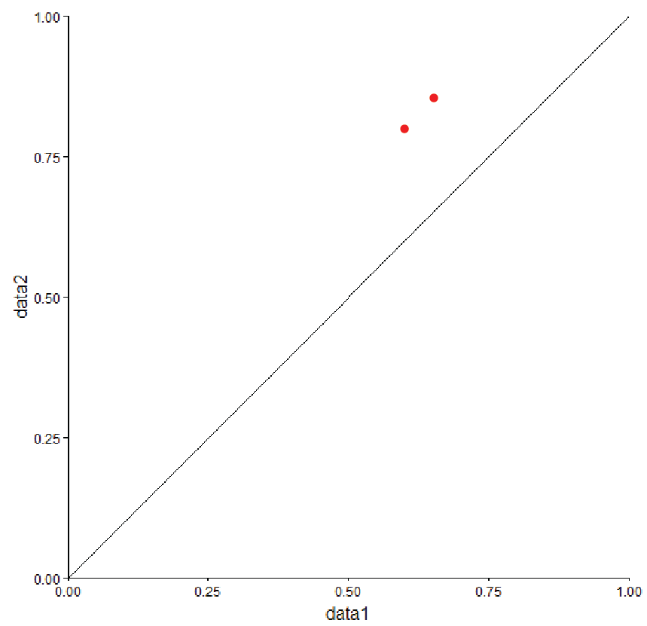

(b).

We have the three data sets and the two models here. We see that the L2-regulized MLR models must be improved to fit the data better.

(6).

(a).

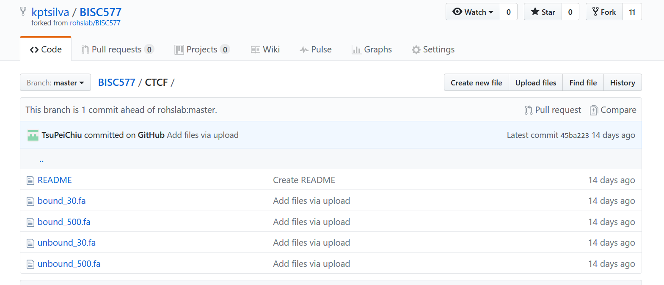

(b).

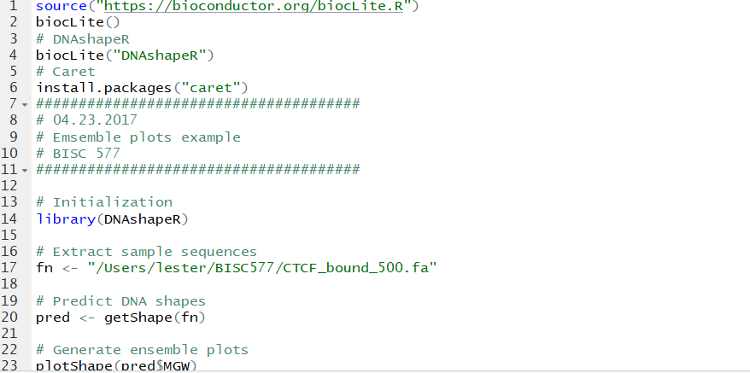

(7).

(a).

Bound: groove width, propeller twist, roll and helix twist

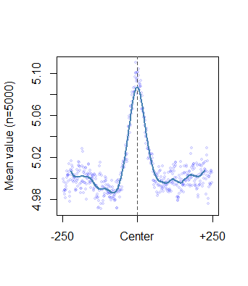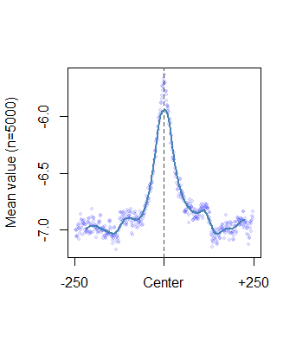

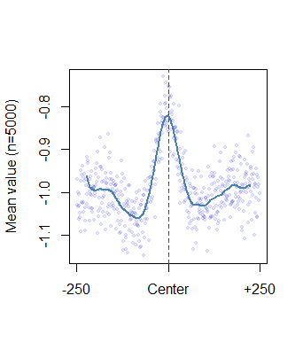

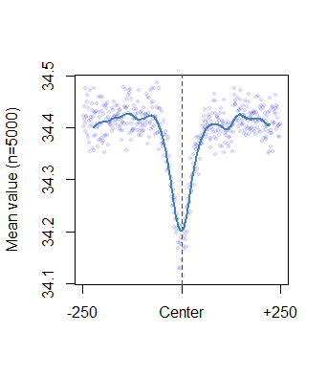

Unbound: groove width, propeller twist, roll and helix twist

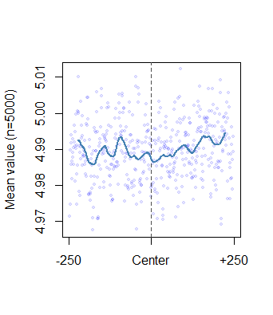

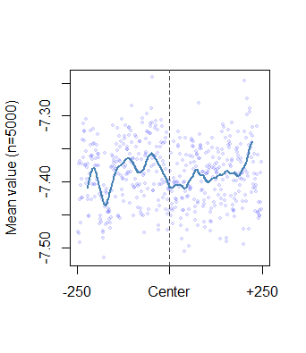

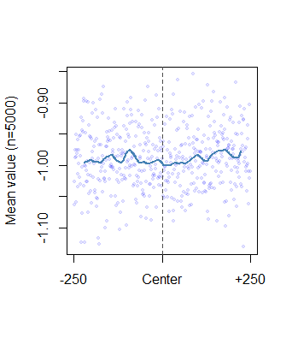

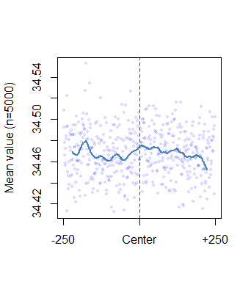

(b). Here we observe that there is a high mean value in the center for the bound states compared to the unbound states in all the DNA shape parameters. This is expected when the DNA is bound since the DNA will under go topological and conformal changes to its shape.

(8).

(a).

1-mer:

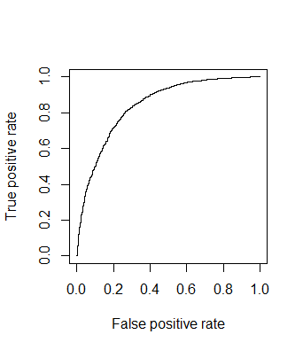

Area if 1-mer was 0.8425398

For 1mer-shape:

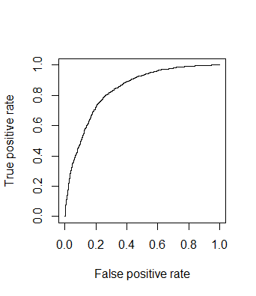

Area if 1-mer-shape was 0.8377216

(b). Based on these AUC scores the regression models seems to be similar for1-mer and 1-mer+shape.